Common Accessibility Errors: And How to Fix Them
- Are you able to navigate the website with a keyboard only?
This checkpoint is important for people with mobility impairments and people using screen readers. They may not use a mouse to navigate the website.
  - Click on the address bar at the top of your browser.
  - Put your mouse under your desk or somewhere where you cannot reach it.
  - Hit tab. Continue hitting tab to see if you can continually access all of the content on the webpage.
  - Be sure that items in drop down menus are either usable from the keyboard (using the Tab or arrow keys) or that all of the information that is in those drop down menus is available on the destination page for the main menu item.
  - Pay attention to the tab order. Does it jump from one side of the page to another? Or does it go in a logical, orderly fashion? (For example, down the left hand column, down the center, and down the right hand column.)

- Can you see where the tab focus is?
People who have mobility impairments who are navigating the website using only the keyboard need to be able to see where they are throughout the page, just like a mouse cursor indicates where you are on the page.
  - When you are tabbing through your webpage, check to see if there is a box outline, an underline, or font color change to indicate where you are on the webpage.
- Is there alternative text on images?
If you don’t supply alt text for the image, a screen reader will read whatever the image title is versus describing what the image actually is. Screen reader software cannot interpret a graphic image, so the image needs to be described in alt text (alternative text description).

  - Open a new tab.
  - Go to the Wave Web Accessibility Tool
  - Enter the URL for your webpage.
  - On the left side of the screen, click on the flag tab underneath the clipboard tab.
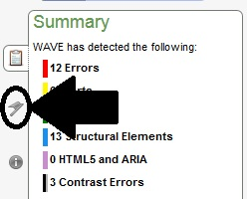
  - Look at the errors denoted in red indicating errors in alternative text or missing alternative text.
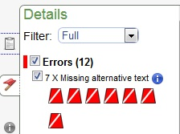
- Is there a video on this page? If so, does it have accurate closed captions?
People who are deaf or hard of hearing need captions to understand what is happening in a video.
  - On the video tool bar, click on the button that says “CC.” (If there is no CC button that means there is no closed captioning.)
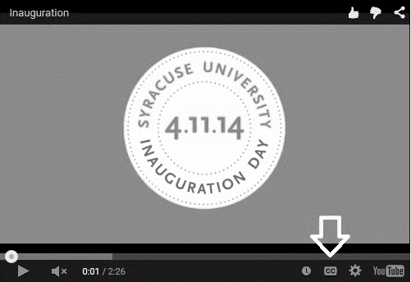
  - If the video has captions, turn the volume on the video totally off. Hit play.
  - Watch the video without sound. See if you can fully understand the message from the captions.

- Are the hyperlinks on the page descriptive and non-repetitive?
People who use screen readers often have their screen reader present them with a list of links. A hyperlink that says “Read More” doesn’t tell them where that hyperlink leads to.
  - Look at the hyperlinks on your webpage.
  - Check to see if any of them say things like “Read more,” “View All,” or “More.”
  - Do any hyperlinks that have the same text lead to different places? For example, two hyperlinks that are “Read More” but lead to different destinations?
  - Check for hyperlinks that are shown simply as the URL rather than displaying a description of the destination page. For example, use Syracuse University Libraries rather than http://library.syr.edu.
- Can you zoom in on the page without losing information? Can you zoom to 200% and still navigate the webpage?
People who have trouble reading small text will often zoom in to see the text. If information is outside the scrolling region when zooming, they cannot get to that information.
  - Press Control and + together until you have doubled the zoom percentage.
  - Check and see if any information on your page is lost.
  - Tab through the page and make sure that everything on the page is still accessible in zoom.
- Is there a ‘skip to content’ or ‘skip navigation’ link?
People who use screen readers don’t want to have to listen to the navigation at the top of each webpage if it remains the same on each page. Having a ‘skip to content’ link lets them jump over the navigation, just like scrolling down a page to the main content would.
  - Using Firefox, go to the menu and select “View.”
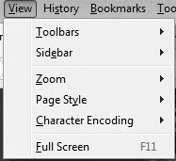
  - Next, in the drop down menu, select “Page Style.”
  - Select “No Style.”
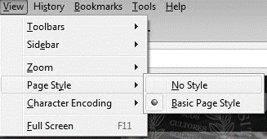
  - Look at the top of the webpage for a hyperlink that says “Skip to Content.”
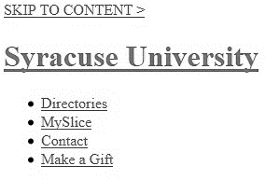
  - If the hyperlink is there, tab to it and press Enter to make sure that it works.
  - If it skips to the content, continue tabbing to make sure that it tabs through the content.

